ASSESSMENT OF PSYCHOMOTOR SKILLS FOR CHILDREN HAVING AUTISM SPECTRUM DISORDER USING LABVIEW

A MINOR PROJECT REPORT

Submitted by

9
ANIRUDH BANIK [Reg No: RA1611002010436]
AMARESH TRIPATHY [Reg No: RA1611002010532]
DHIRAL PANCHAL [Reg No: RA1611002010540]
DHWAJ AGRAWAL [Reg No: RA1611002010580]

Under the guidance of
VASANTHKUMAR CH, (PhD)
(Assistant Professor)

DEPARTMENT OF MECHANICAL ENGINEERING

FACULTY OF ENGINEERING & TECHNOLOGY



S.R.M. Nagar, Kattankulathur, Kancheepuram District
NOVEMBER 2019

SRM INSTITUTE OF SCIENCE & TECHNOLOGY
(Deemed To be University, Under Section 3 of UGC Act, 1956)

BONAFIDE CERTIFICATE

Certified that this minor project report titled “ASSESSMENT OF PSYCHOMOTOR SKILLS FOR CHILDREN HAVING AUTISM SPECTRUM DISORDER USING LABVIEW” is the bonafide work of “AMARESH TRIPATHY, DHIRAL PANCHAL. DHWAJ AGRAWAL, ANIRUDH BANIK”, who carried out the minor project work under my supervision. Certified further, that to the best of my knowledge the work reported herein does not form any other project report or dissertation on the basis of which a degree or award was conferred on an earlier occasion on these or any other candidate.

SIGNATURE SIGNATURE

of of

GUIDE HEAD OF THE DEPARTMENT

Signature of the Examiner-I Signature of the Examiner -II

ACKNOWLEDGEMENT

First of all, we would like to thank the almighty for the successful completion of this training.
We would like to thank HOD/Mechanical, School of Mechanical Engineering SRM Institute of Science and Technology for allowing me to undertake this project for the 7th semester in 2019.
We would like to extend our gratitude to our project guide Vasanthkumar CH sir who has helped guide us over the last few months in completing this project. The completion of this project would not have been possible without his help.
Finally, we would like to thank everyone else who has helped us along the way to see this project through.

ABSTRACT

Autism Spectrum Disorder (ASD) is a developmental disorder that affects a large number of children from an early age. In 2018, it was estimated that 1 in every 59 children were diagnosed with Autistic Spectrum Disorder whereas the number in 2014 was 1 in every 68 children. Most ASD interventions are highly expensive and government funded interventions often have very long waiting times. Mechatronic kits previously designed were limited by the number of input components.

The aim of our project is to help assess the degree of autism that the child has so that, later, the child may be given the proper level of care and treatment that is required. Using our mechatronic kit, we can use various parameters to assess the degree of autism using the different input components and sensors, through the use of an Arduino interface and LabView. This kit can be made easily available and is relatively easy to use and transport.

TABLE OF CONTENTS

CHAPTER NO. TITLE PAGE NO. ACKNOWLEDGEMENT i

ABSTRACT iii

INTRODUCTION 1

1.1 | ABOUT AUTISM | 1
1.2 | BLOCK DIAGRAM | 2
1.3 | MECHATRONIC KIT DETAILS | 2
 | 1.3.1 INPUT DEVICES | 2
 | 1.3.2 OUTPUT DEVICES | 3
 | 1.3.3 INTEGRATION | 4
1.4 | BASIC 3D MODEL | 5
1.5 | CONNECTOR DIAGRAM | 6
1.6 | CODES | 7
1.7 | SCALE FOR ASSESSMENT | 8
1.8 | LAB VIEW | 9
  - LITERATURE REVIEW 10

3. CONCLUSION 12

INTRODUCTION

ABOUT AUTISM:

Autism Spectrum Disorder (ASD) is a type of developmental disorder that affects a child as young as 4 years. In 2014, the number of children affected by ASD was seen to be 1 in 68 according to the United States Centres for Disease Control and Preventions. However, recent studies conducted by CDC in 2018 has shown the number to increase to 1 in 59. It has been widely recognized for many decades that the vast majority of autistic persons are quite unimpaired with regard to their finger dexterity and gross motor capabilities. They have in fact often been described as especially dexterous and coordinated. Individuals on the spectrum often experience difficulties with social communication and interaction and restricted, repetitive patterns of behavior, interests, or activities. Symptoms are typically recognized between one and two years of age. Long-term problems may include difficulties in performing daily tasks, creating and keeping relationships, and maintaining a job.

The cause of autism spectrum is uncertain. Risk factors include having an older parent, a family history of autism, and certain genetic conditions. It is estimated that between 64% and 91% of risk is due to family history. Autism is characterized by persistent deficits in social communication and interaction across multiple contexts, as well as restricted, repetitive patterns of behavior, interests, or activities. These deficits are present in early childhood, and lead to clinically significant functional impairment. Autism spectrum disorders include a wide variety of characteristics. Some of these include behavioral characteristics which widely range from slow development of social and learning skills to difficulties creating connections with other people. Psychomotor deficits are generally characterized by impairments regarding joint attention and poor nonverbal communication skills such as lack of eye contact and meaningful gestures and facial expressions.

BLOCK DIAGRAM

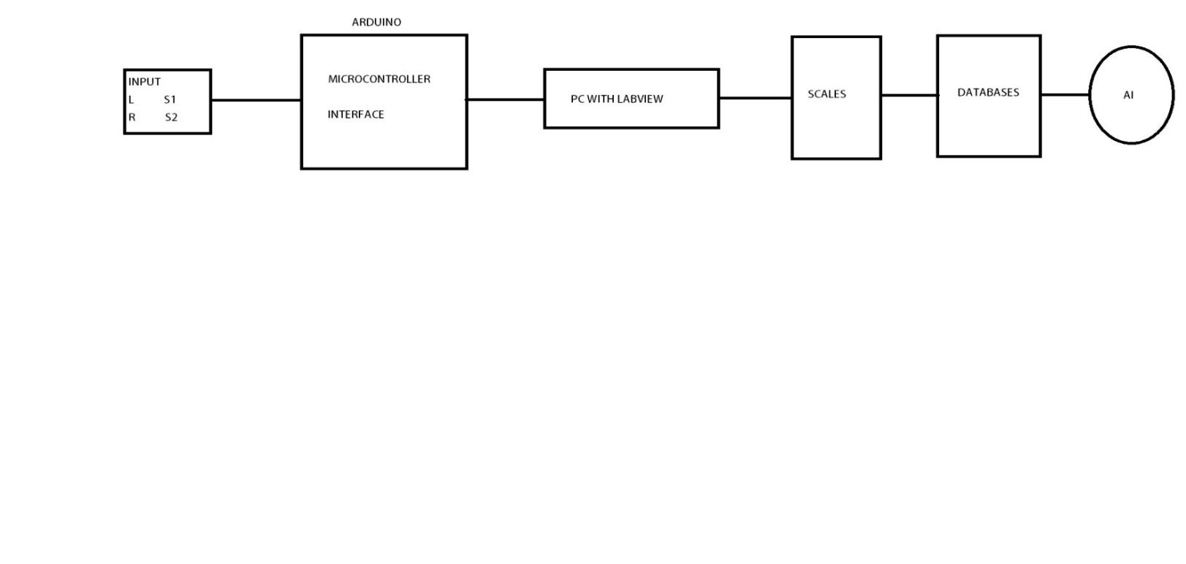 As seen in the figure, the input signal will be transferred through the sensors and are then integrated by the Arduino microcontroller. This will then be sent to the PC which will store the data using LabView. We will then be using this data to correlate it to the MACS scale.

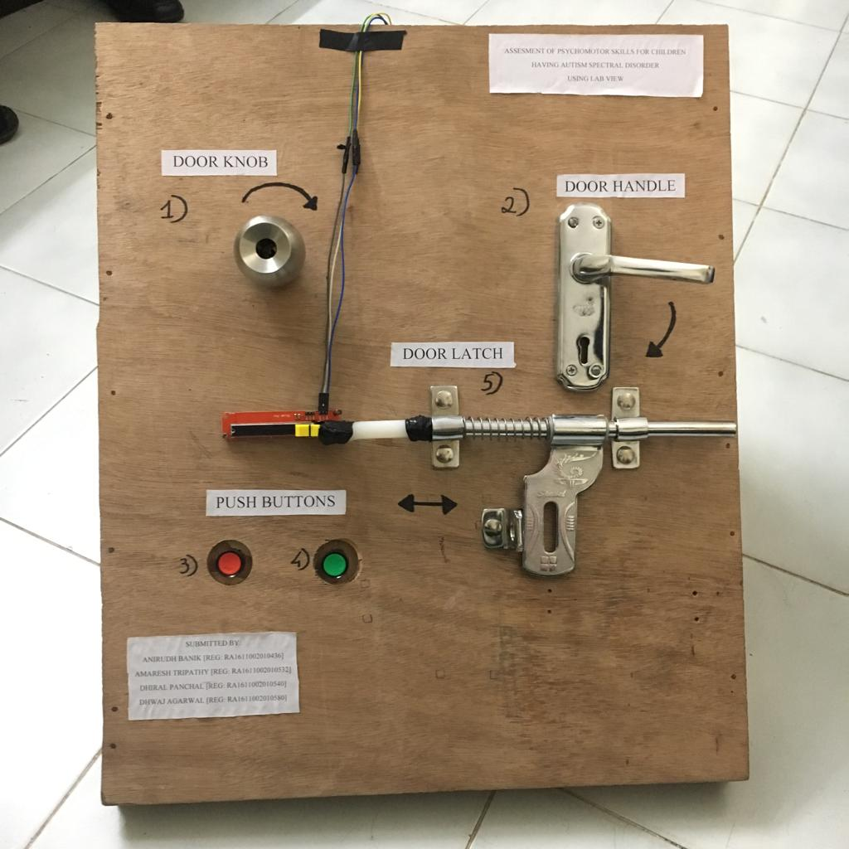

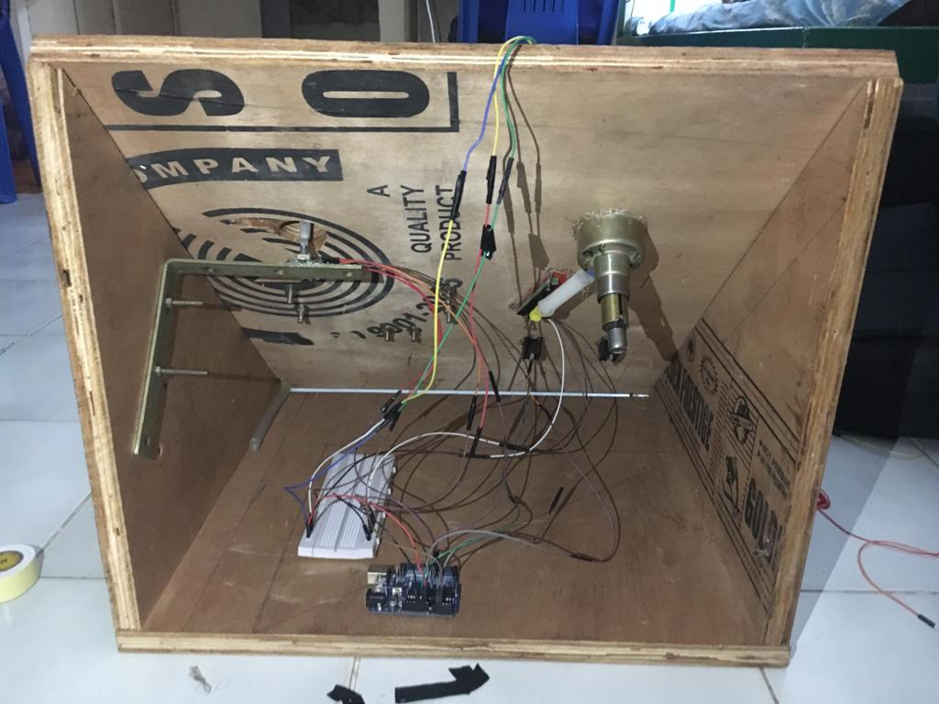

MECHATRONIC KIT DETAILS

The kit that is being designed will be used to determine the degree of autism that the child is suffering from. The kit focuses on assessing the gross motor skills and the fine motor skills of the child. For this purpose, we will be using different input sources namely a door knob, door handle, door latch and two push buttons. Sensors are used to extract data from the input devices. There are individual sensors connected to each of the input devices. For example, the door knob is connected to a linear potentiometer. These sensors are then integrated with the help of an Arduino microcontroller which is connected to a computer. This allows us to receive real time data from the inputs as the child operates the input devices.

INPUT DEVICES

- Door Handle: The door handle will test the palmar grasping capability of the child while also testing their wrist mobility and their hand eye coordination. The other end of the handle is connected to a rotary encoder. So as the child turns the handle, the corresponding values will be generated by the encoder in terms of voltage and this will be fed into the computer through the Arduino microcontroller.

- Door Knob: As previously stated, the knob will be connected to a linear potentiometer. The purpose of the door knob is to test the gripping strength of the child as well as the aforementioned hand eye coordination. This will again give outputs in the form of voltages and be read in the computer.

- Door Latch: Similar to the door handle, the latch will be testing the palmar grasping capability but, in this case, it will also test the shoulder stability as well as the elbow mobility that the child has. This will again give outputs in the form of voltages and be read in the computer.

- Push button: Alcom 4v 250 amp SPDT switch .In case of the push buttons, we will be measuring the duration for which the buttons are being pressed. This will assess the finger mobility and hand stability of the child. The push button is a Single Pull Double Throw (SPDT) switch. There is no output device associated with the push button as it is an electrical switch from which the data values can be directly obtained.

OUTPUT DEVICES
In case of the output devices, there are mainly two output devices that will be used:

- Linear Potentiometer: ElectroBot 10K Linear Slide Adjustable Potentiometer Module | B07QQ21LBR (10K Slider Pot) is the potentiometer that will be used to generate the output in voltage. This type of sensor reads the linear displacement and similar to the rotary encoder, converts the encoded position into analog or digital signal.
This linear potentiometer will be connected to the door handle as well as the latch to measure the linear displacement in both these instances. For the door handle, there will be a small notch that is displaced linearly whenever the handle is turned and this notch will be the measurand in this case. In case of the door latch, its displacement is simply measured by the movement of the latch itself. All this will again be converted into voltage outputs which can again be measured and noted through LabView.
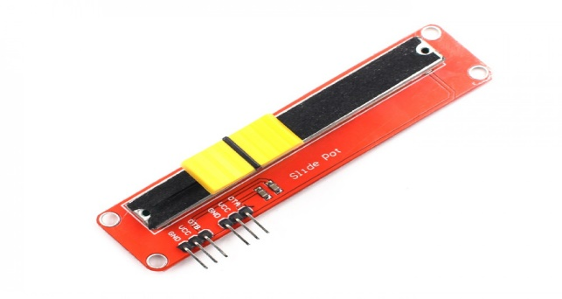
- Rotary encoder: Core Technologies Rotary Encoder Module | B01HI92TRW (45-16Y4-EB5P) The rotary encoder is capable of converting angular position or motion of an object into digital output signals. The type of rotary encoder used here is an absolute rotary encoder. The rotary encoder will be connected to the end of the door knob to measure the twisting force developed when the door knob is turned. This will then give us and output in terms of voltage which will be measured and noted. This encoder will be connected to an Arduino unit which will directly send the data to a computer which will be used to store using LabView.

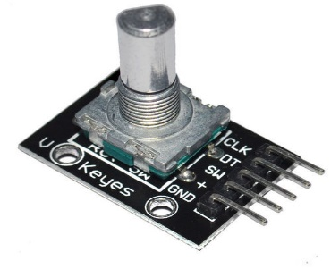

INTEGRATION

We will be integrating all the output sensors with the Arduino UNO microcontroller. The connector diagrams have been illustrated below. Jump wires is used to connect different ports of different sensors to the Arduino.

In case of the push button, the VCC port is connected to the 5V port of the Arduino, ground to ground, Ver/Y to A0 and Hor/X to the A1 ports respectively. The range for this device is 0 - 10 seconds.

For the linear potentiometer, VCC port is connected to the 5V port, ground to ground as in the push button and OLV to the A2 port of the Arduino. The linear potentiometer for Door Latch has a range of 0 - 95 units and that for the Door Knob is 70 - 85 units.

For the rotary encoder, the + port is connected to the 5V port, ground to ground, CLK is connected to port 2 and OT is connected to port 3. This device has a range of -1 – 6 units.

MODELLING

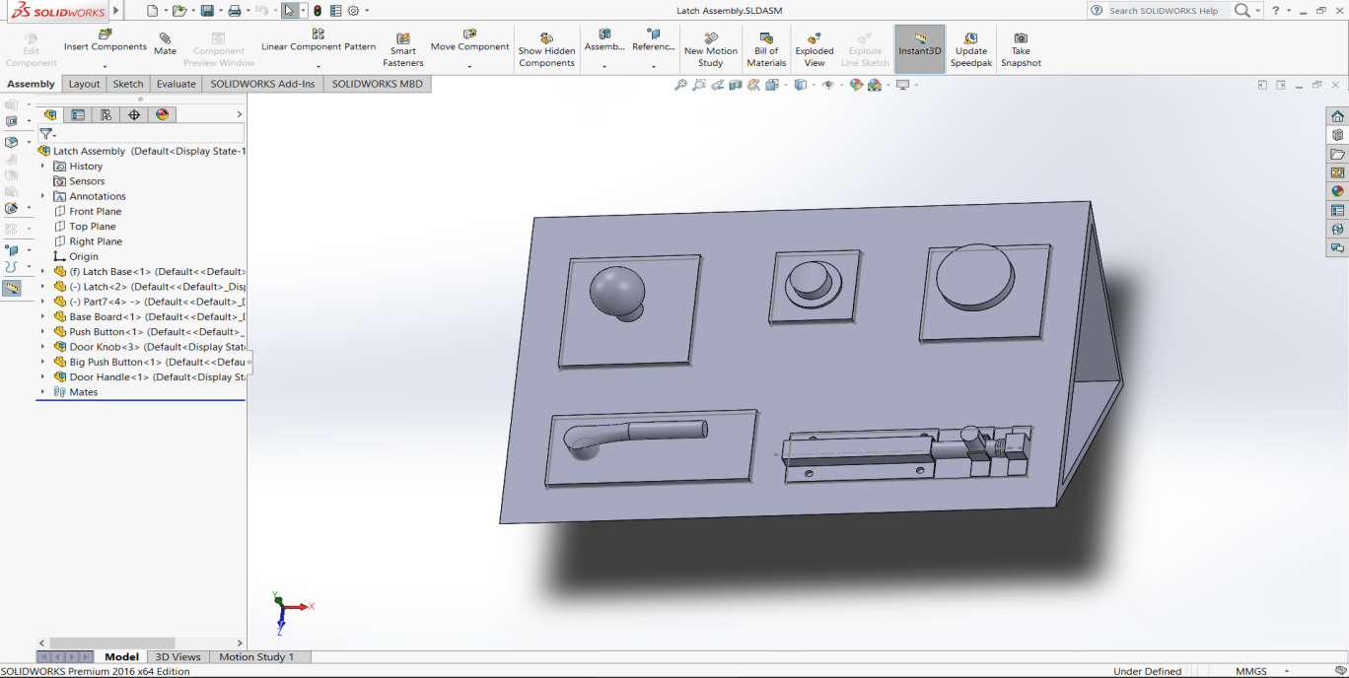

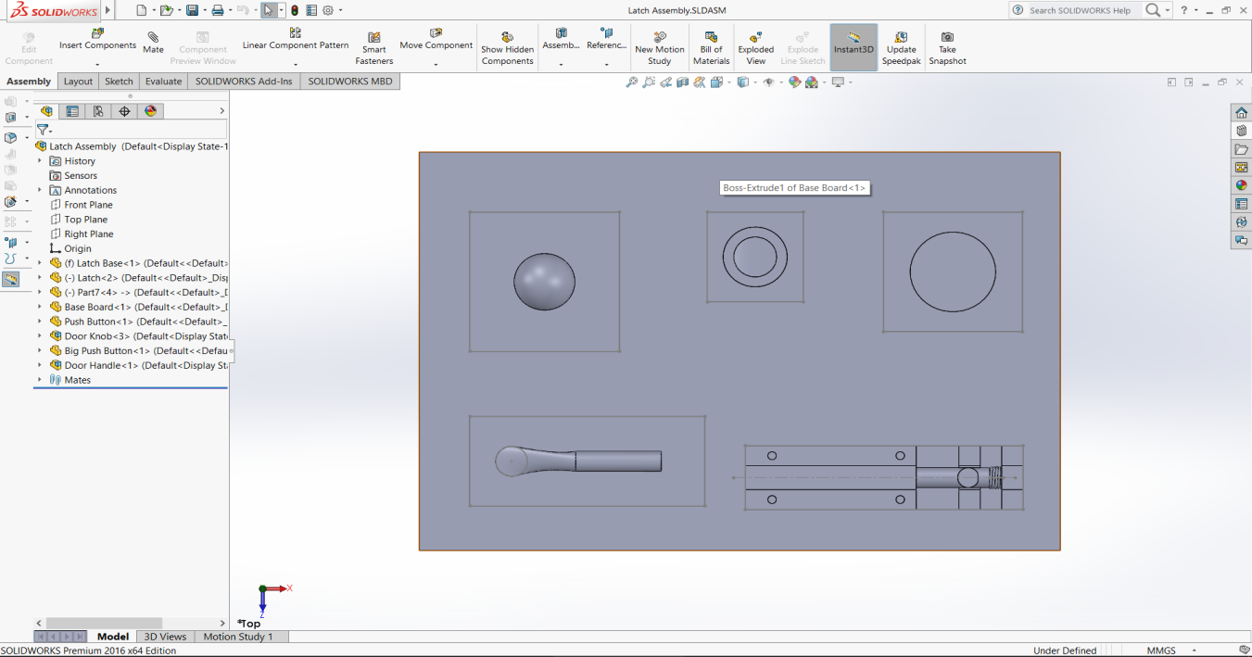

CONNECTOR DIAGRAM

- Linear potentiometer to Arduino

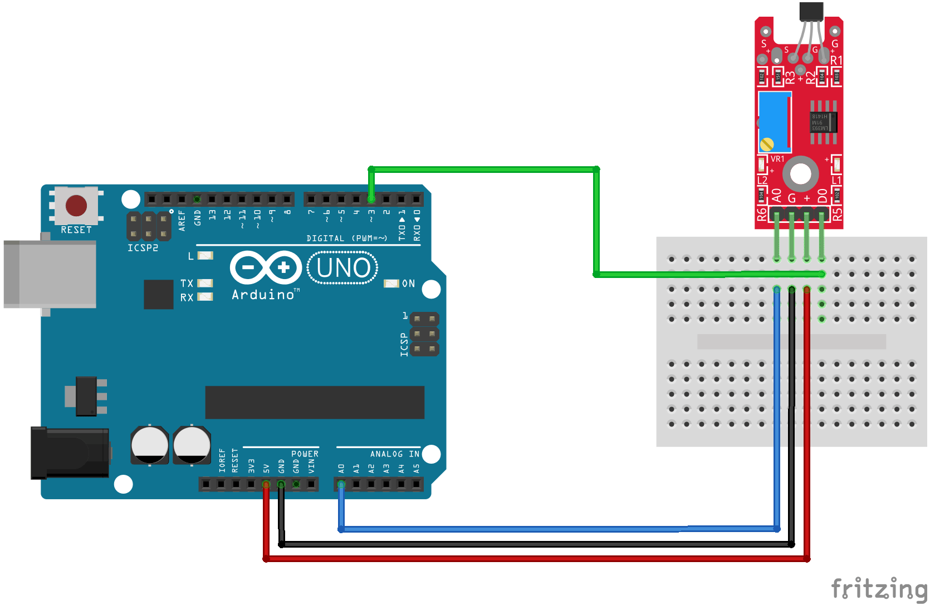

- Rotary encoder to Arduino
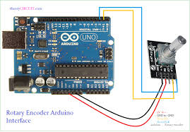

- SPDT Switch to Arduino

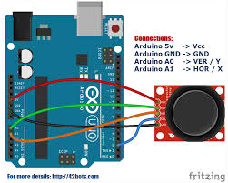

SCALES FOR ASSESSMENT

MACS Scale:

- The ability of children from 4 – 18 years old with cerebral palsy to handle objects in everyday activities can be categorised into 5 levels using the Manual Ability Classification System (MACS).
- MACS level is determined based on knowledge about the child’s actual performance in daily life. It is not done by conducting a specific assessment, but by asking someone who knows the child and how that child typically performs.
- MACS levels:
- MACS Level I
- Objects are handled easily and successfully.
- MACS Level II
- Handles most objects but with some reduced quality and/or speed.
- MACS Level III
- Handles objects with difficulty – the child will need help to prepare and/or modify activities.
- MACS Level IV
- Handles a limited selection of easily managed objects and always requires some help from others.
- MACS Level V
The child is not able to handle objects or to complete even simple actions with their hands.

Assessment of Scales:

- We will make the child use the input devices one after another. This is done to test the number of input devices the child can operate.
- Next, depending on the number of input devices the child can operate, we will be checking the output values received from the sensors to determine the degree of efficiency with which the child is able to operate the input devices.
- Finally based on the above criteria we will be categorising the child on the MACS Scale and then further elaborate that with the output data received from the sensors.

LAB VIEW
What is VISA READ function?
It Reads the specified number of bytes from the device or interface specified by VISA resource name and returns the data in read buffer. VISA resource name specifies the resource to be opened. The VISA resource name control also specifies the session and class byte count is the number of bytes to be read.

This function might return less than the number of bytes requested if the function reaches the end of the buffer, reaches a termination character, or if a timeout occurs. The output error cluster indicates if a timeout has occurred.

String to Decimal number conversion:
Use the Scan from String function (Functions Palette » String).
Specify a format string that tells the function what to look for in the input string. To edit the format string right click on the Scan from String icon and choose Edit Scan String. The pattern for specifying the decimal separator is the percent sign followed by the decimal separator you choose followed by a semi-colon.

Writing data to LabView Measurement files:
- Add the Write To Measurement File Express VI to the block diagram.
- In the File Format section, select the format for the file to which you want to write data.
- In the Segment Headers section, select the header option for the file.
- Configure the X Value Columns section if you selected Text (LVM) in the File Format section and you plan to view the data in a spreadsheet or text editor.
- Configure the remaining sections in the Configure Write To Measurement File dialog box and click the OK button to save the configuration and close the dialog box.
- Add the Simulate Signal Express VI to the block diagram and configure the VI. Then wire the output of the Simulate Signal Express VI to the Signals input of the Write To Measurement File Express VI. Wire all error in and error out terminals on the block diagram.
- Run the VI. The VI writes the data from the Simulate Signal Express VI to the file specified in the Filename section of the Configure Write To Measurement File dialog box.
- To view the data you saved, open the output file with a spreadsheet or word processing application if it is a .lvm file. Use the file path displayed in the Filename section of the Configure Write To Measurement File dialog box to access the file.
LITERATURE SURVEY

Paper 1: Enhancement of psychomotor skills in children with autism spectrum disorder by employing a mechatronic training kit, published 2018. This paper focuses on enhancement of psychomotor skills in children with ASD by employing a mechatronic training kit. Significant improvements were seen in these children both in skills and in behaviour after the training.

Paper 2: Autism Spectrum Disorder – An Indian Perspective, published 2018. The main discussion of this paper deals with Autism Spectrum Disorder (ASD) which affects around 3 million people in the Indian subcontinent and is being increasingly recognized as an important issue.

Paper 3: The Manual Ability Classification System (MACS) for children with cerebral palsy: scale development and evidence of validity and reliability, published 2006. This paper details the Manual Ability Classification System (MACS) which has been developed to classify how children with cerebral palsy (CP) use their hands when handling objects in daily activities.

Paper 4: Introduction to the Pediatric Evaluation of Disability Inventory Computerized Adaptive Test (PEDI-CAT) for Children with Cerebral Palsy (ASD), published 2015. This paper discusses the applicability of the PEDI-CAT to measure abilities in youth with disabilities including psychometric properties specifically for youth with CP (GMFCS Levels I-V and MACS I-V).

CONCLUSION

We brought two children for the purpose of assessing the degree of the autism they are facing using the MACS Scale. The result for the children is as follows:

SL NO | INPUT DEVICE | CHILD 1 | CHILD 2 | RANGE
1 | DOOR KNOB | 1 (74 UNITS) | 1 (81 UNITS) | 70 - 85
2 | DOOR HANDLE | 0 | 0 | -1 - 6
3 | PUSH BUTTON (RED) | 0 | 1 (3 SECONDS) | 0 - 10
4 | PUSH BUTTON (GREEN) | 0 | 0 | 0 - 10
5 | DOOR LATCH | 1 (33 UNITS) | 1 (57 UNITS) | 0 - 95

So, from the above readings, we can conclude that Child 1 is classified under MACS Level II and Child 2 is classified under MACS Level III. (If 2 or more children fall under the same MACS Level, then we will differentiate them based on the percentage of the input device they have operated successfully)

Therefore, the mechatronic kit has been developed and the assessments for the Autism Spectral Disorder of children has been completed.

